Dessa Shapiro

10/8/19

Loving Family

In the book I Am Malala the first part of the section I read not much had changed in Malala’s life since the last blog entry where that Tabilan had run out by the military. Malala’s life has continued to stay the same, not exactly good, but normal. She continued to go to school and hanging out with her friends. She also continued to stress about school and strive to be the best and to make a difference in her society. In the story, one day after school Malala was taking the bus home after school, her parents refused to let her walk because she was still getting threats from the Taliban. One day after school she got on the bus with her friends. While they were one the bus a group of Taliban soldiers stopped the truck and got in. They had rifles with them and said “Who is Malala? “

After that, one of the Taliban soldiers started shooting. They shot Malala in the head and they also shot a few of her friends that were sitting next to her. The bullet passed close to Malala’s eye and into her soldier. Thankfully there was no serious damage but the hospital did transfer Malala in a helicopter to a better hospital. Malala was unconscious and although the bullet did not directly hit her brain there was still some swelling in her brain from fragments of the bullets. The doctors ended up removing some of Malala’s skull to stop the swelling in her brain. After the swelling had gone down they reattached her skull. After a while, Malala’s condition started to worsen. Her father was very worried about her.

` Her father had a friend whose daughter had died when she was only 16 years old and when he called Malala’s father this is what he said “ My father cried.‘Tell me how can one live without daughters,’ he sobbed.”(pg. 260) I feel that I relate to this passage because there are a lot of things in this world that I love. And even though I have a very different lifestyle then Malala, but I know what it’s like to love what you don’t know what you would do if they are gone. I can empathise with Malala’s father because I can imagine what It would be like to lose one of my parents. When I was a first grader my father had to travel away for a month for his job. Back then I was still a little kid and I didnt think he would ever come back. I was so scared I cried almost every night he was gone. So, I can imagine what Malala’s father felt when he thought he had lost his beloved daughter forever. I also feel like in this passage the author brings the reader into the story and makes them feel what Malala’s father was feeling. I know that unless someone I love is in critical condition I will never be able to fully empathize with Malala’s father because I will never have the same experience. I also think that this part of the story resonates with me because my parents and I have always gotten along and I have a good relationship with them. I think that since I have a good relationship it would be that much harder to lose one of them, then for some other people.

**Song: foster the people, pumped up kicks**

I think this song relates to this passage because It talks about kids in a school shooting and Malala was in the same kind of scenario when she was shot on the bus.

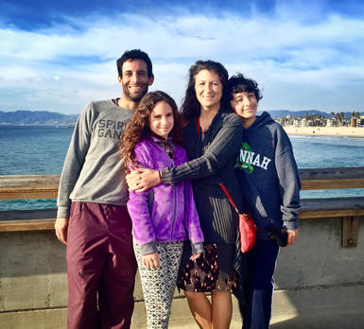

This is a picture of my family